CSA 0976 Programming in Java

Name: M.Varun

Reg no: 192111007

Assignment 5

1.Code:

import java.applet.Applet;

import java.awt.\*;

import java.awt.event.ActionEvent;

import java.awt.event.ActionListener;

import java.awt.event.WindowAdapter;

import java.awt.event.WindowEvent;

public class EventHandlingApplet extends Applet implements ActionListener

{

Button button;

String message;

public void init()

{

button = new Button("Click me!");

add(button);

button.addActionListener(this);

message = "";

}

public void actionPerformed(ActionEvent event)

{

if (event.getSource() == button)

{

message = "Hello, world!";

}

repaint();

}

public void paint(Graphics g)

{

g.drawString(message, 50, 50);

}

public static void main(String[] args)

{

EventHandlingApplet applet = new EventHandlingApplet();

applet.init();

Frame frame = new Frame("My Applet");

frame.add(applet);

frame.pack();

frame.addWindowListener(new WindowAdapter()

{

public void windowClosing(WindowEvent event)

{

System.exit(0);

}

});

frame.setVisible(true);

}

}

Output:

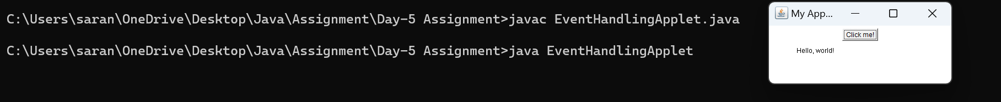

2.Code:

import java.io.\*;

class FileIOExample

{

public static void main(String args[])

{

try

{

FileOutputStream fos = new FileOutputStream("output.txt");

String message = "WELCOME TO SSE";

fos.write(message.getBytes());

fos.close();

FileInputStream fis = new FileInputStream("output.txt");

byte[] bytes = new byte[fis.available()];

fis.read(bytes);

fis.close();

String readMessage = new String(bytes);

System.out.println(readMessage);

}

catch (IOException e)

{

System.out.println("Error: " + e.getMessage());

}

}

}

Output:

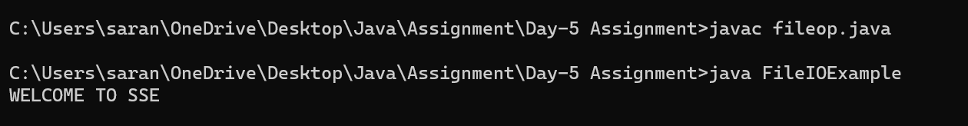

3.Code:

import java.util.Scanner;

class captialuse

{

public static void main(String[] args)

{

Scanner scan = new Scanner(System.in);

System.out.print("Enter a word: ");

String word = scan.nextLine();

boolean isRightUsage = true;

boolean allCaps = true;

boolean noCaps = true;

for (int i = 0; i < word.length(); i++)

{

char c = word.charAt(i);

if (Character.isLowerCase(c))

{

allCaps = false;

}

else

{

noCaps = false;

}

if (!allCaps && !noCaps)

{

isRightUsage = false;

break;

}

}

if (isRightUsage || allCaps || noCaps)

{

System.out.println("The usage of capitals in \"" + word + "\" is correct.");

}

else

{

System.out.println("The usage of capitals in \"" + word + "\" is incorrect.");

}

}

}

Output:

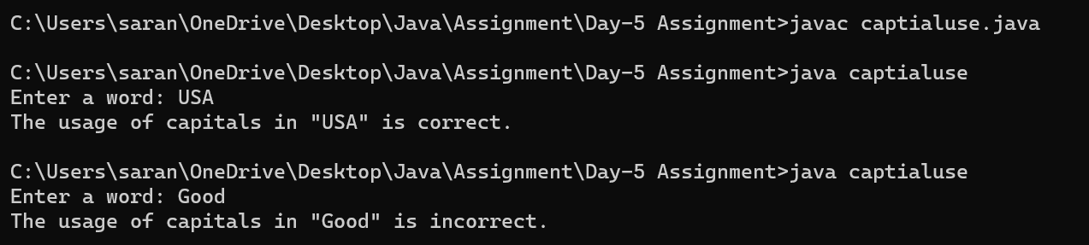

4.Code:

import java.util.Arrays;

class upperch

{

public static char nextGreatestLetter(char[] letters, char target)

{

int n = letters.length;

int left = 0, right = n - 1;

while (left <= right)

{

int mid = left + (right - left) / 2;

if (letters[mid] <= target)

{

left = mid + 1;

}

else

{

right = mid - 1;

}

}

return left >= n ? letters[0] : letters[left];

}

public static void main(String[] args)

{

char[] letters = {'c', 'f', 'j'};

char target = 'a';

char result = nextGreatestLetter(letters, target);

System.out.println("Input: letters = " + Arrays.toString(letters) + ", target = " + target);

System.out.println("Output: " + result);

}

}

Output:

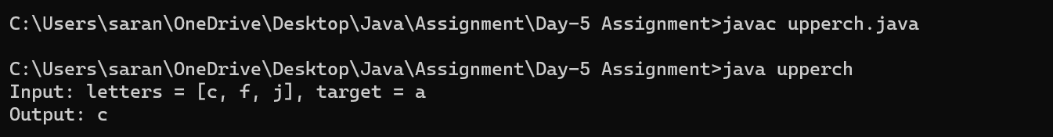

5.Code:

import java.util.Scanner;

public class Menusel

{

public static void main(String[] args)

{

Scanner scan = new Scanner(System.in);

char choice;

do

{

System.out.println("Help on : ");

System.out.println("1. if");

System.out.println("2. switch");

System.out.println("3. while");

System.out.println("4. do-while");

System.out.println("5. for\n");

System.out.print("Choose any one : ");

choice = scan.next().charAt(0);

} while(choice < '1' || choice > '5');

System.out.println("\n");

switch (choice)

{

case '1':

System.out.println("The if :\n");

System.out.println("if(condition)\n{\n\tstatement\n}");

System.out.println("else\n{\n\tstatement\n}");

break;

case '2':

System.out.println("The switch :\n");

System.out.println("switch(expression)\n{");

System.out.println("\tcase constant: statement sequence\n\tbreak;");

System.out.println("\t//...\n}");

break;

case '3':

System.out.println("The while :\n");

System.out.println("while(condition)\n{");

System.out.println("\t// body of loop\n}");

break;

case '4':

System.out.println("The do-while :\n");

System.out.println("do\n{");

System.out.println("\t// body of loop\n\n}while(condition);");

break;

case '5':

System.out.println("The for :\n");

System.out.println("for(initialization; condition; iteration)\n{");

System.out.println("\t// body of loop\n}");

break;

default:

System.out.println("Invalid choice!");

}

}

}

Output:

